1. Strategic Analysis 1200 words Ying

* Historical Analysis 200 words
* External Analysis and Market Based View 200 words
* Internal Analysis and Resource Based View 200 words
* Organizational Analysis and Organisation Based View 200 words
* Corporate Analysis ( if it is a Corporate Case ) 200 words

(History)

Starbucks was established in Seattle, USA in 1971 and today, there are 17,009 stores in 50 countries. Starbucks product range includes coffee, handcraft beverage, merchandises, fresh food, and brand portfolio. The number of employees is 142,000 in the world and 111,000 in US. Sales in 2010 were US$10,71billion in the world and US$7,56billion in US. US is the biggest market for Starbucks and it accounts for approximately 70% of sales.

Starbucks are in 50 countries such as UK, China, Mexico, NZ, Russia, Brazil etc. Basic menu of beverage is 6 types which are Brewed coffee, Chocolate Beverages, Espresso Beverages, Frappuccino Blended Beverages, Kid’s Drinks and Teas, however, the rage of menu depends on the countries. That is why there is wide rage of menu in the world. For example, tastes of Sakura in Japan

During 2002-2006, the company's revenues, operating profit and net profit grew at a CAGR of 24%, 28.6% and 28.6% respectively. Moreover, the company's average return on equity and return on investment during 2002-2006 were 19%, and 18% respectively, significantly higher than the industry averages of 15.3% and 11.3%. Though it suffers decline during the year 2007 and 2008, it is still one of the most stable and fast growing companies in the year 2008. Robust financial performance enhances investor confidence and strengthens the financial position of the company.

Starbucks has be greatly successful in the last decade and as we can see from the graph, the company’s net earnings has been increasing with remarkable yearly percentage ( more than 10% per year) until 2008.

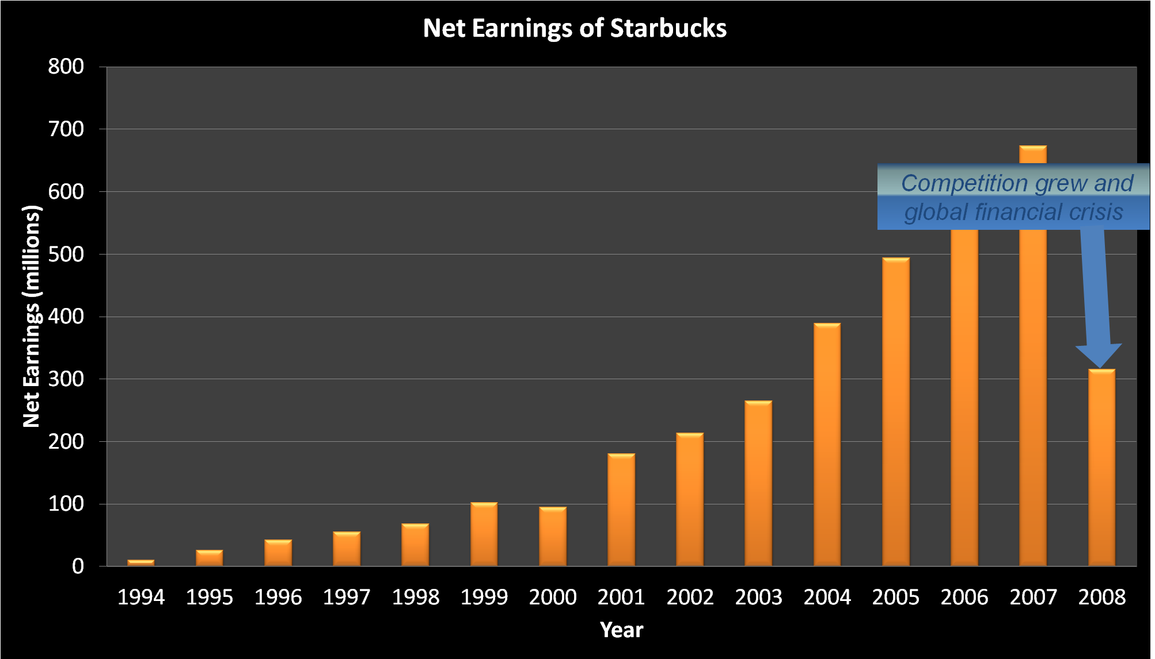

**Porter's Five Forces Analysis**

The threat of entry: low.

Starbucks is a company that have years of experience in roasting specialized coffee, if a company was to enter the coffee industry it would be extremely difficult for them to offer the same quality of coffee at a competitive price.

The power of buyers: high.

Starbucks does face a high buyer power challenge because of the nature of the industry. The customers demanding for coffee have no switching costs to change their brand choice. This implies that the cost leadership strategy in this industry will tend to suffer severe competition and surprisingly low profit.

The power of suppliers: low.

Starbucks buy their coffee beans directly from producing countries: Latin America (50%), Pacific Rim (35%) and East Africa (15%). The company’s fixed-price and price-to-be-fixed supply chain gives it a certain level of power against suppliers.

The threat of substitutes: high.

Starbucks is facing great substitute challenges of cheaper coffee provided by competitors, and ‘coffee-at-home’ maker machines. All the instant/homemade (caffeinated) drinks such as juice, cola, water, can be a substitute threat to Starbucks.

Competitive rivalry: high.

Starbucks is mainly facing rivalry from catering establishments (fast food industry) such as McDonalds’, which is exploring the market of premium coffee, as well as others such as Dunkin’ Donuts and Burger King; it also has other small stores or imitators as competitors (e.g. Caribou), but they contribute comparatively little to the intensity of the competition according to the data presented. Starbucks competes with a variety of smaller scale specialty coffee shops, mostly concentrated in different regions of the country. All of these specialty coffee chains are differentiated from Starbucks in one way or another. Starbucks faces severe competition in some of the global markets, mainly from the Italian coffee store Illy and other already-well-developed local/global companies (e.g. Costa Coffee).

**Competitor analysis**

Competitor Analysis

The main competitive forces at work can be summarized as the following:

Catering establishments (Mcdonald’s or similar catering establishments), specialist coffee chains/imitators (Calibou or similar specialty coffee store), global markets’ local competitors (Illy or similar premium coffee provider), fine coffee makers for home-made coffee (Nestle or similar instant coffee and coffee machine supplier), minor competition include other kinds of drink product suppliers.

The Strategic Group Analysis mapping can be seen as follow:

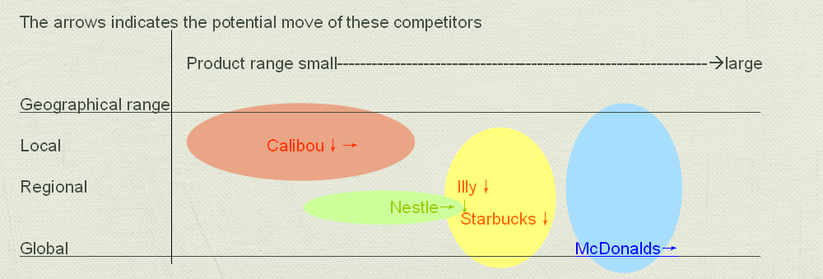

Competition is steadily growing against Starbucks each year as the industry grows. Competitors look to gain an advantage by price cuts, launching a rival product, aggressive expansion of production to increase market share or inclusion of significant modifications to a product that other competitors must also undertake to keep up. At the end of 2008, Dunkin’ Donuts was close to Starbucks in number of retail stores with 8,835 stores worldwide, including 6,395 franchised restaurants in thirty-four US states and 2,240 international shops in thirty-one countries. The following are the current figures showing the market share of companies in the coffee industry.

The two significant competitors in this year will be McDonald’s and Caribou. The competitors’ information will be provided in following text.

McDonald’s

The company will be installing coffee bars along with "baristas" who will serve cappuccinos, lattes, mochas and the Frappe, a knockoff of the Starbucks’ ice blended Frappuccino, throughout 2008 and into the beginning of 2009. The competitive threat posed by McDonald's can be summarized by referring to the February 2008 edition of the Consumer Reports magazine, which rated the McDonald's drip coffee as better tasting than Starbucks. (Adamy, McDonald's Takes on Starbucks, 2008)

Caribou coffee

Caribou Coffee is similar to Starbucks in their attempt to create a third-place. Where Starbucks strives to create an upscale European atmosphere, Caribou coffee tries to implement a more American feel to their coffee houses. They do this by modeling their coffee houses after rustic Alaskan lodges. (Quelch, 2006) In addition, they offer free WiFi, drive through accessibility and meeting rooms for rent. Founded in 1992, Caribou coffee now operates roughly 500 stores, employs over 6000 people and grosses roughly $230 million in revenue a year. (Caribou Coffee, 2008)

**SWOT analysis**

**Starbucks’ current internal position can be evaluated as this SWOT mapping:**

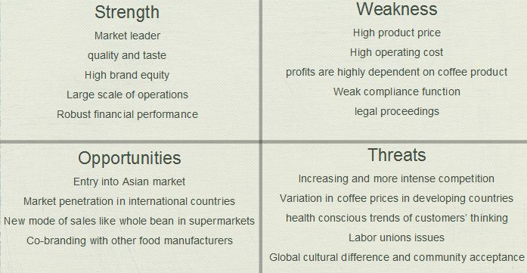

**Stakeholder analysis**

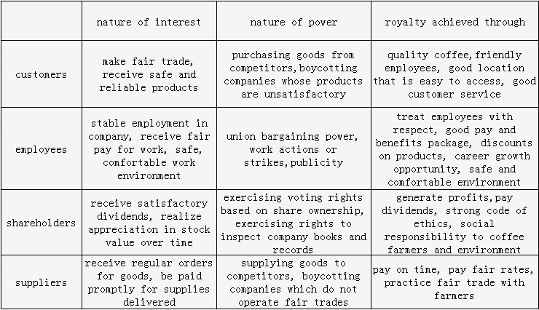

Starbucks could take some measures to change the stance of specific stakeholders to a more optimistic one and to enhance the power of them. For instance, customer X can be stimulated to bolster the proposed strategy and help Starbucks by supplying media access, or even convincing customer Y that the change can be good. Also, if community, which represents the attitude of local people to Starbucks, could be shifted to group D, it will become one of the important indicators for Starbucks’ decision to locate their stores. Community mainly determines the popularity and acceptability of Starbucks in local, so Starbucks can make use of this truth to gain more benefits by increasing connection with customers and community.

**KSF**

* First mover advantage
* Cultural fitting of USA and other global markets( hundreds of years of coffee drinking)
* Excellent customer service and store environment---Starbucks tries to offer a “third place”, where people can get away from the daily routines of their lives and enjoy a cup of coffee from Sumatra, Kenya or Costa Rica. It is a place where the noise and hostility ever present in the city dissipates. Most important, it is a place that offers casual social interactions.
* Good reputation of brand and product (more company controlled stores than franchising) . (Shultz, Pour Your Heart Into It: How Starbucks Built a Company One Cup at a Time, 1997, p. 114)
* Continuous introduction of new product
* Rising consideration and commitment to environment issues
* Good relation to employees (employee satisfaction)—health care benefits (not only attract higher-quality employees but would decrease the turnover rate and potentially decrease the overall expenses for the company); employee stock ownership plan affectionately referred to as Bean Stock
* Good relation and reputation to coffee suppliers---Starbucks saw an opportunity to encourage social change by forming a strategic alliance with conservation international.
* Suitable choice of location

-------------------------------------------------------------------------------------------------------------

Starbucks’ success thus far can be attributed to five primary factors. The first of these factors was their ability to design a strategic approach to growth that quickly demonstrated the feasibility of their business model and took advantage of some key demographic groups. Next was there ability to attract the highest-quality employees through the implementation of a superior healthcare plan while reducing costs and giving equity ownership to all employees. The strategic alliance they had with conservation international allowed them to create a sustainable supply chain of high quality coffee.

The three previous factors helped enable them to foster the fourth factor in their success, a community environment in which casual social interactions could take place. The fifth 34factor to their success was there ability to adapt to the changing dynamics of their consumer demographics. All of these factors have allowed them to stay at the forefront of the specialty coffee industry.